A brief summary of the Regular meeting of Queen’s College, Taunton Lodge 6988 on 13.5.2023

It was a packed agenda - the consequence of a lodge which meets just four times a year, attended by 50 brethren.  Apart from the usual matters including minutes, approval of Accounts and Officers reports, we were delighted to welcome **Bro Charlie White** as an Initiate.  An OQ and local Funeral Director, he was supported by his Grandfather, Bro Dave Breed, Lodge St George 3158.  WBro Jim Virjee gave an almost flawless 'Charge to the Initiate'.  A 'Masonic Chain' was formed and explained for Bro Charlie's benefit.

VWBro John Winston, PPrDGM then presented the Somerset PGM's 50th Anniversary Certificates, adding remarks which were not too incriminating, (!) to WBros Geoff Perrin and Richard Baker, both of whom addressed the Lodge briefly.

This was followed by separate ballots for two proposed new members - as a Joining Member, OQ Bro Jamie Cullen living at Bruton and then as an Initiate, Mr Frazer John Bell of Shepton Mallet.  Both ballots were unanimously in favour.

At the conclusion of the meeting approximately 50 brethren dined when the usual toasts were honoured.  WBro Jonathan Dolling sang the 'Initiates Song' with Bro Barry Renwick on piano.  Alms in Lodge, a draw, single auction item and 'heads&tails' produced over £700.

*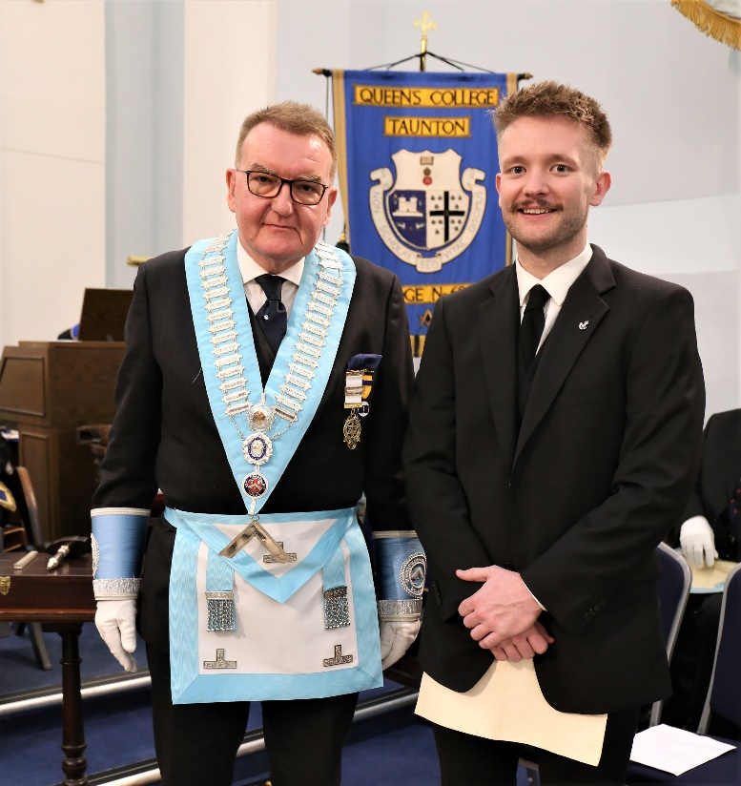Initiation of Charlie White, OQ aged 24, Funeral Director, with Wm WBro Lindsay Edmunds and his Grandfather, Bro Dave Breed, 13th May 2023* 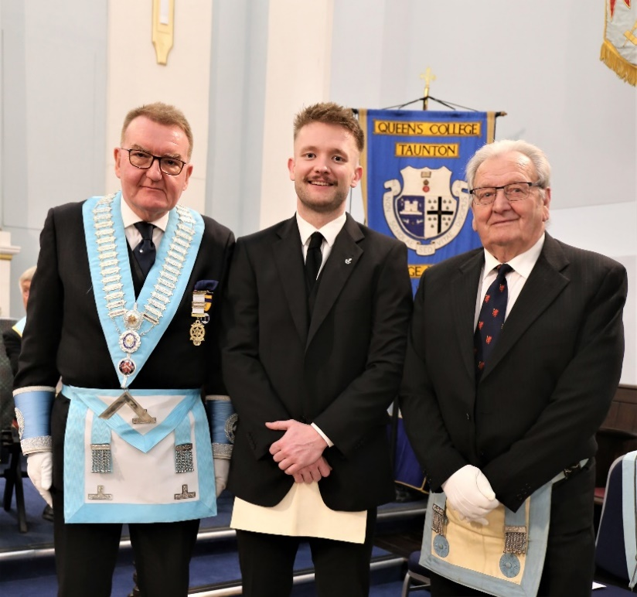

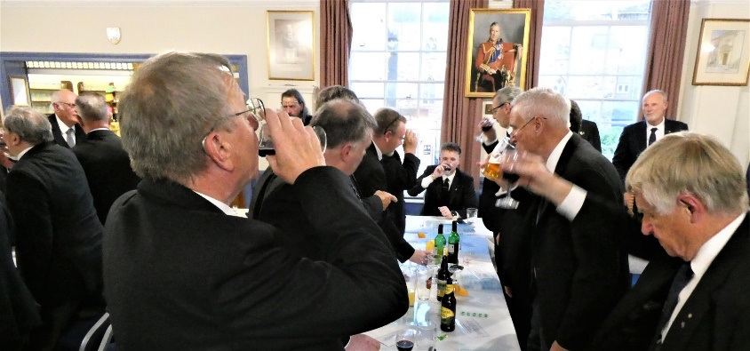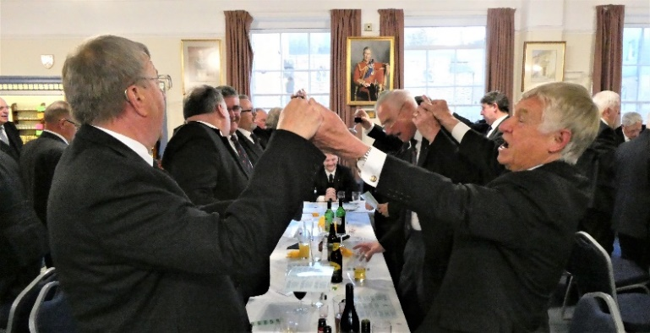*WBro Jonathan Dolling led the Initiate’s Song accompanied by Bro Barry Renwick on piano.*

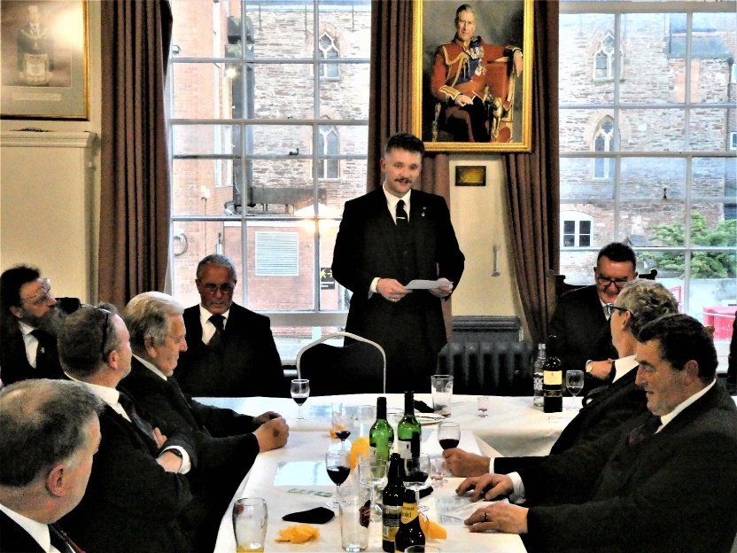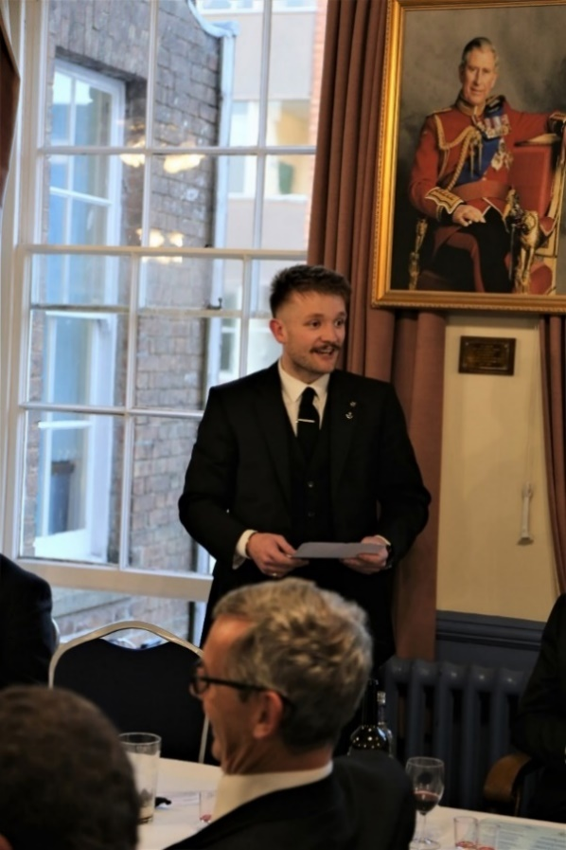‘Fire’ was given. Bro Charlie responded to his toast with an appropriate and confident reply.

***Following the Initiation Ceremony*** came the presentation by VWBro John Winston, PPrDGM, of two 50th Anniversary Certificates to WBros Geoffrey Perrin and Richard Baker.

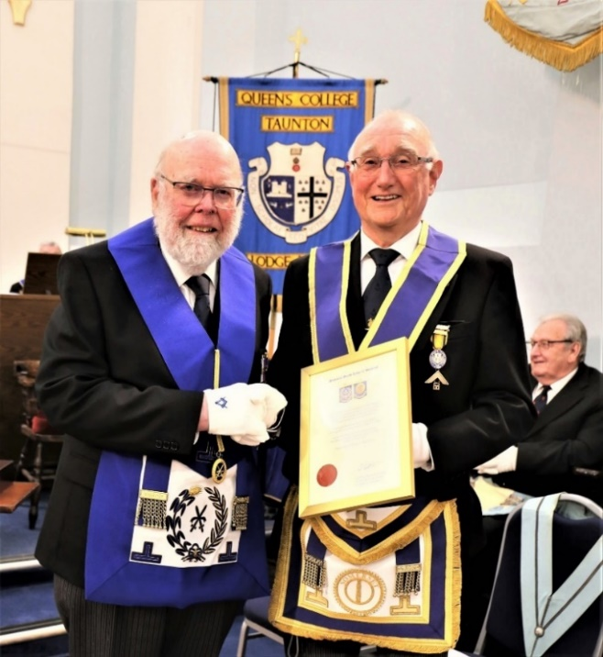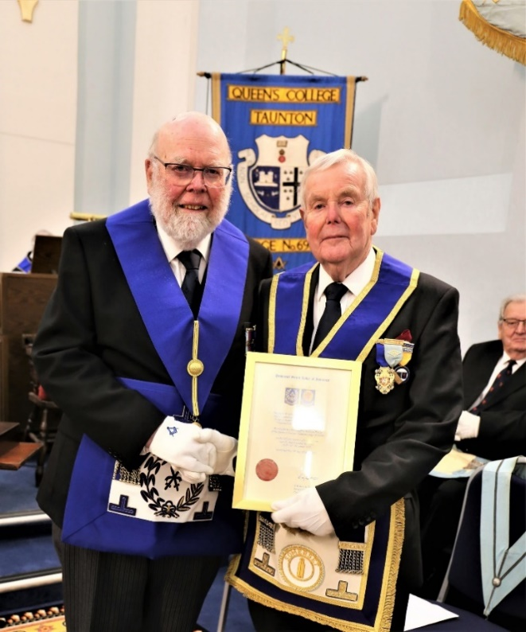WBro Geoff Perrin was initiated in to Salem Lodge 1443, Dawlish late in 1972. This certificate would have been presented at the Christmas 2022 meeting had he not been house-bound recovering from a complex heart operation at the BRI. He has been coming to 6988 as a guest of WBro Geoffrey Dolling for many years having moved to Taunton. When, in 2012, lodge membership criteria changed, he became a Joining Member. WBro Richard Baker was initiated in to 6988 on Saturday, 13th May 1973 – WBro Andy Rodgers conducted that ceremony as Wm. This presentation was therefore, 50 years to the day! WBro Richard started boarding at Queen’s College at the age of 8 in 1955 along with WBros Lionel Frewin & Jim Wiltshire.

*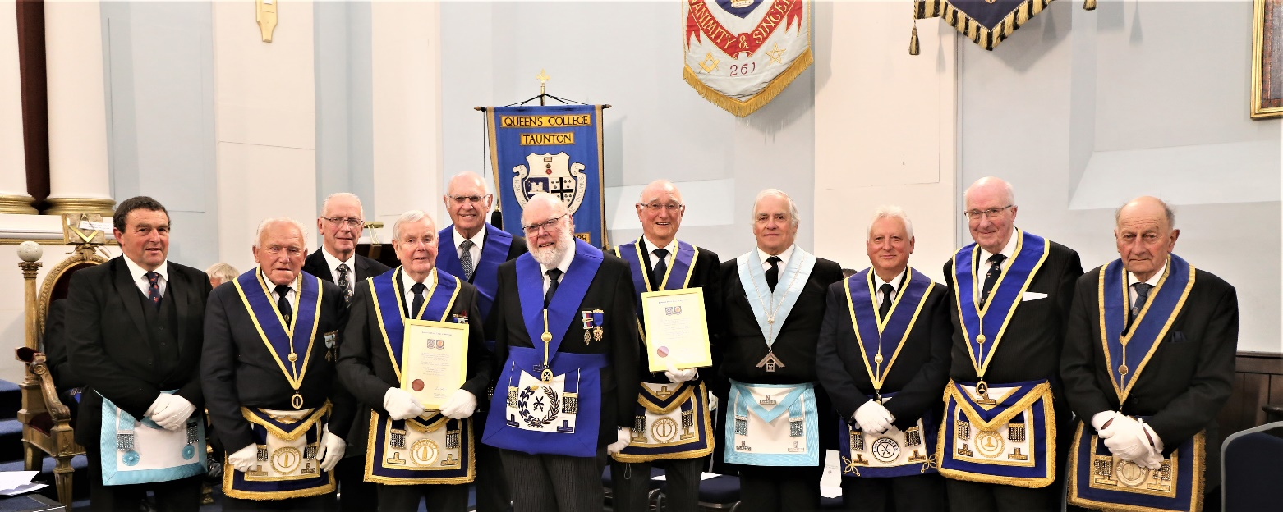Geoffrey & Richard pictured with their guests, coincidentally, all from Devon, except one!*

*Photos thanks to WBro Jim Wiltshire, Charity Steward, who stood in as Inner Guard as well!* ***RB***