**QUEEN’S COLLEGE, TAUNTON LODGE 6988 Installation 18.3.2023. (RBB)**

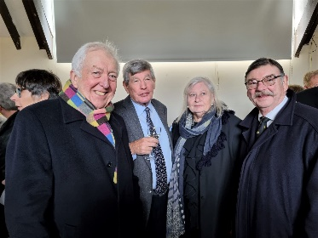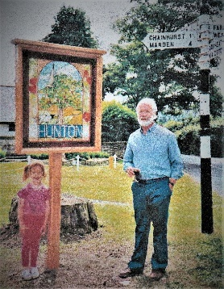If you have had the minutes of our Installation Meeting on Saturday 18th March, you will know we had a very full agenda with nearly 70 in attendance. Having received the Provincial party, WBro Andy Rodgers called Brethren to order to give a eulogy about the Late Bro Roger M Sawtell who passed to the Grand Lodge Above aged 84 on 30th January. At Queen’s 1947-57, and initiated in to Queen’s 6988 November 1978, following his late father. Roger lived with his wife Ann and family at Hunton in Kent for many years. WBro Lionel Frewin and Bro Tony Wade attended a packed Memorial Service for him in February when they met Joe Lulham, another OQ and great friend of Roger. The Brethren stood to order in silence in respect for Departed Merit.

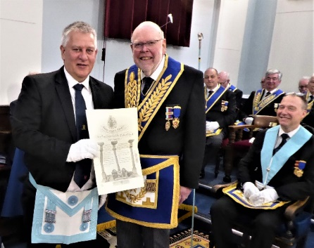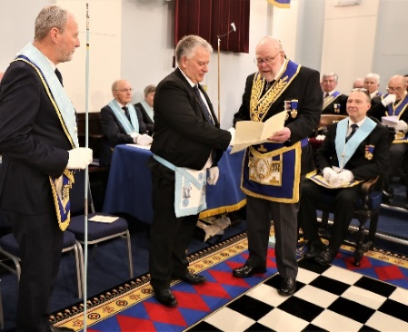Another item which preceded the Installation Ceremony was the long- awaited presentation of a Grand Lodge Certificate to Bro Richard Brown, delayed by the incidence of Covid and then holiday, carried out by the experienced and very wise VW Bro John Winston, PPDGM. PHOTOS, WBro Jim Wiltshire

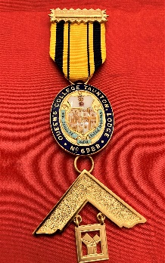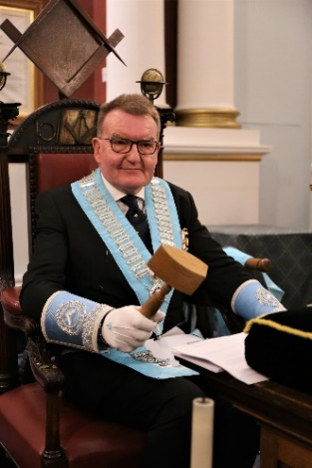The Worshipful Master, WBro Ray Conneely, assisted by many Brethren and under the watchful eye of WBro Tony Guthrie, Assistant Provincial Grand Master, Ray proceeded with the Queen’s College 6988 ‘Extended Working of a Board of Installed Masters’ Ceremony to instal WBro Dr Lindsay Edmunds who was Presented by WBro Grahan Ten Broeke. On the successful conclusion of the ceremony, newly installed Wm Lindsay thanked IPM WBro Ray and invited WBro Guthrie to present Ray with the Queen’s 6988 PM Jewel donated back to the lodge by WBro David Simpson, the original recipient following his year as Wm in 1986.

WBro Lindsay is photographed flanked by WBro Tony Guthrie, APGM and IPM WBro Ray Conneely with (L-R) DC WBro Andy Humphries, SW WBro Jonathan Dolling and JW WBro Dr Keith Pickavance.

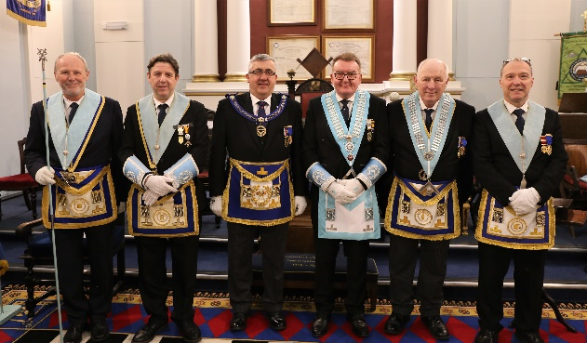

Worshipful Brother Lindsay was then able to assemble the majority of his officers

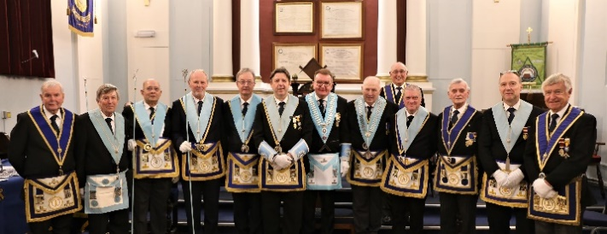

At the closing of the Installation Ceremony, Alms were collected, as usual, during the Closing Ode. Wm Lindsay invited a guest first to sing the National Anthem in Welsh before all Brethren followed with the first verse of the National Anthem. Alms collected amounted to £425.50 to be further enhanced by £90 from those who donated using the Gift Aid Envelope Scheme. With raffle, etc, added, a wonderful £1,066 became the total to be donated in due course to WBro Lindsay’s chosen charity, Open Door, Taunton for the Homeless.

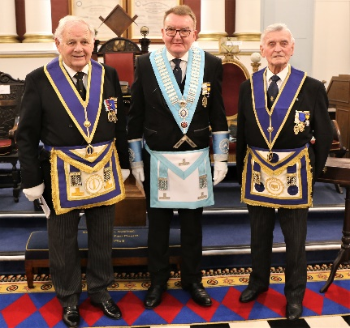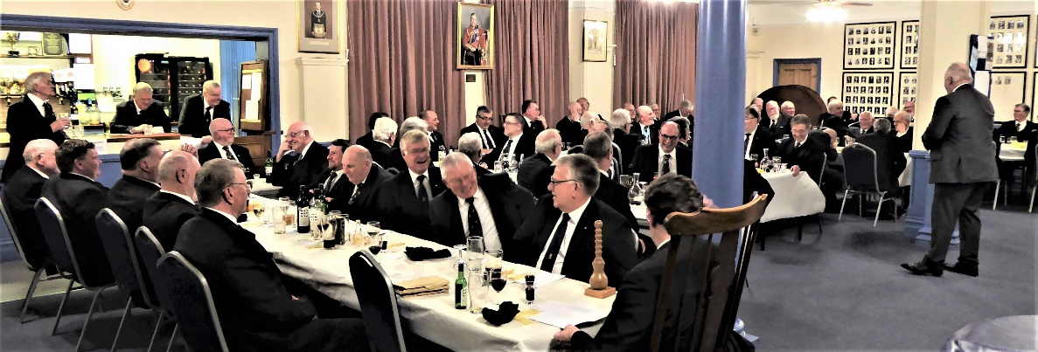At an excellent Festive Board the usual toasts were honoured. WBro Jonathan Dolling sang the Wm’s Song accompanied by Bro Barry Renwick, on piano, pictured (L-R) WBro Graham; Wm Lindsay; Bro Barry.

