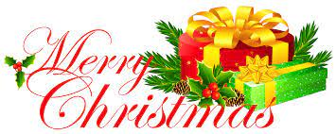*Queen’s Lodge CHRISTMAS 2022 Review – IT’S ALL CHANGE!*

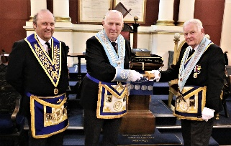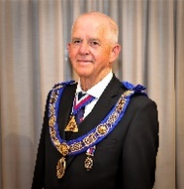Having started 2022 cautiously, the theme became – ‘out with the old and in with the new’! During the year we lost our excellent Somerset Provincial Grand Master RW Bro David Medlock to the dizzy heights of Grand Lodge as Assistant Grand Master. Recently, he installed his successor, RW Bro Ray Guthrie. After a covid enforced 3-year tenure our own Worshipful Master, WBro Graham Ten Broeke passed his gavel on to W Bro Ray Conneely in March; our Wm Ray also took on the busy ‘active’ Provincial role of PJGW.

W Bro Mike Kinnersley, our exemplary Almoner wished to step aside after 19 years in that role. Who better than W Bro Dr Jim Virjee who volunteered to take up the challenge? It was only a week later and following our Wm Ray, when Dr Jim also accepted an ‘active’ Provincial role as PJGD! Gluttons for punishment, nevertheless a great honour for them!

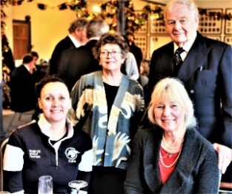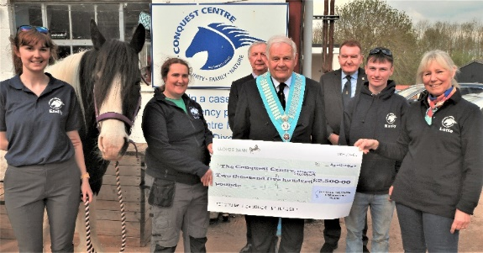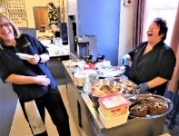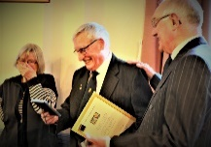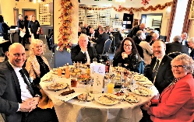“*Happy to meet again*” our Christmas meeting 2021 was a cautious affair with just 45 dining (90 pre covid) after the briefest of formal meetings, a talk by Conquest Centre guests and a sparkling reception. The photos illustrate the happy mood with seating at round tables. W Bro Andy Rodgers was presented with his 50th anniversary certificate, plus a little extra! The Christmas fare was excellent, as usual, while the Alms collection, raffle and auction conducted by WBro Geoff Dolling in his inimitable style raised a further £900. With this, previous donations, and a £500 contribution from our Provincial Office we were able to present £2,500 to the Conquest Centre.

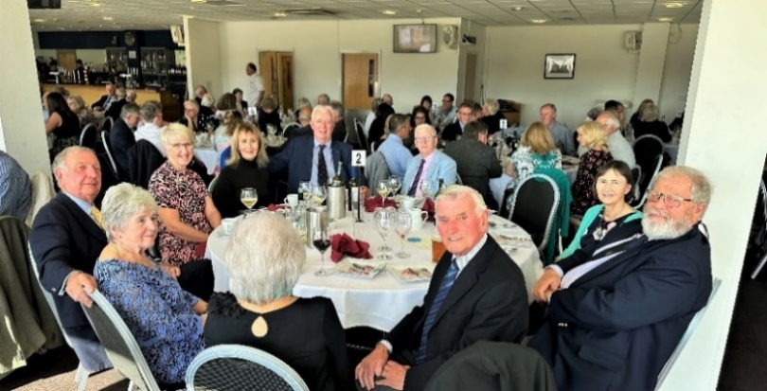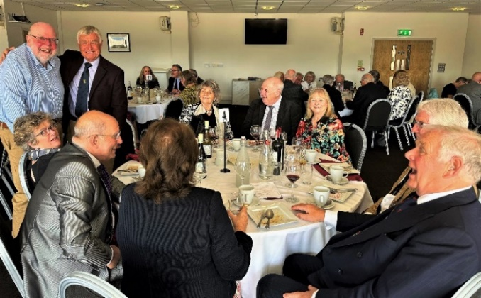The Somerset Masonic Friendship Association held their annual lunch at the Taunton Cricket Club as usual in October: VW Bro John Winston is their Chairman. Queen’s Lodge had two tables;

an excellent meal was enjoyed amid much good humour.

**OF COURSE, MASONIC MEETINGS** **CONTINUED** with renewed vigour as the year developed. During the Summer Recess our Masonic Hall was refurbished and the exterior of the building was redecorated.

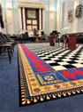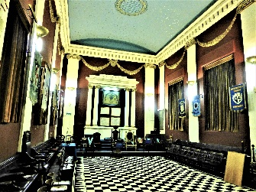**OLD**   **NEW**



**At his installation in March, W Bro Ray announced that all donations that evening should go to the Masonic Charitable Appeal ‘Ukranian Appeal’. An incredible £3,000 was raised; Queen’s Lodge Charity Fund added a further £2,000; the sum of £5,000 was the largest contribution from any of the 85 Craft Lodges in Somerset!**

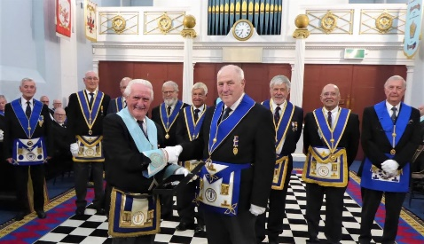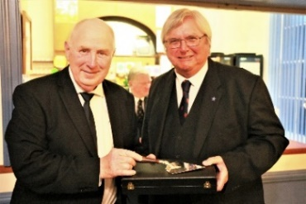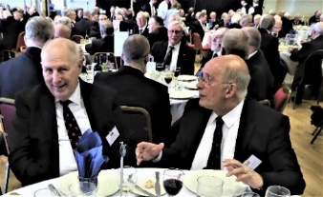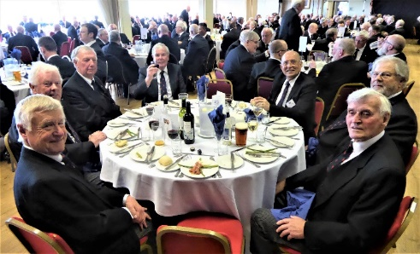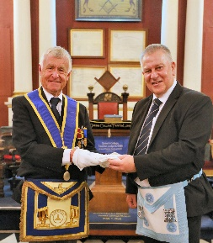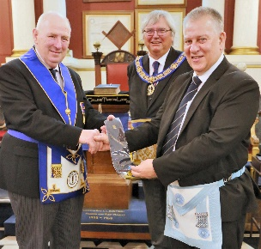Early **April** brought the annual Provincial Grand Lodge meeting when W Bros Ray and Dr Jim both accepted ‘active’ roles for twelve months. How busy they would be! Eleven of us were there to support them among a gathering of 350/400, 250 of whom dined. At our Regular meeting in **May** we were honoured by the presence of RW Bro David Medlock, PGM who had a specific duty in mind – to start a ‘Travelling Trowel’ on it’s two-year journey from one lodge to another. At that meeting, Bro Richard Brown was the focus of attention being Raised to Master Mason. He was presented with a lodge tie by Wm Ray and gloves, in memory of his late father, by W Bro Mike Kinnersley. On the **6th** **October**, accompanied by eight members of Queen’s Lodge, W Bro Ray presented that Trowel to Harry, WM of Taunton Dean Lodge.

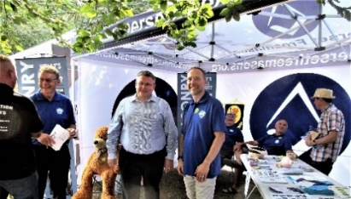Taunton Freemasons organised the Provincial Gazebo for the two-day Flower Show in **August**. Queen’s Brethren - Geoff Dolling, Geoff Perrin, Phil Jubb and Keith Pickavance helped out.

In **September**, RW Bro David Medlock was elevated to Assistant Grand Master at a meeting of Grand Lodge. W Bros Lionel Frewin, Ray Conneely and Keith Pickavance were delighted to have received tickets for this prestigious occasion. **On Saturday 24th September** the Taunton Masonic Hall was open to the public. The Provincial Gazebo was erected in High Street. In the Dining Room where display boards were erected, refreshments were served. Brethren from Queen’s Lodge included W Bros Geoffrey Dolling, Geoff Perrin, Philip Waterman and Wm Ray Conneely. OQ, W Bro Simon Johnson, our Guest Tyler, was also helping out.

On 8th **October**, we were honoured to receive an exceptional number of guests representing a Provincial Fraternal Visit led by W Bro Martin Slocombe, Past Assistant Provincial Grand Master. During the course of the evening, over £1,270 was raised for our Wm’s charity choice – Somerset & Dorset Air Ambulance.

